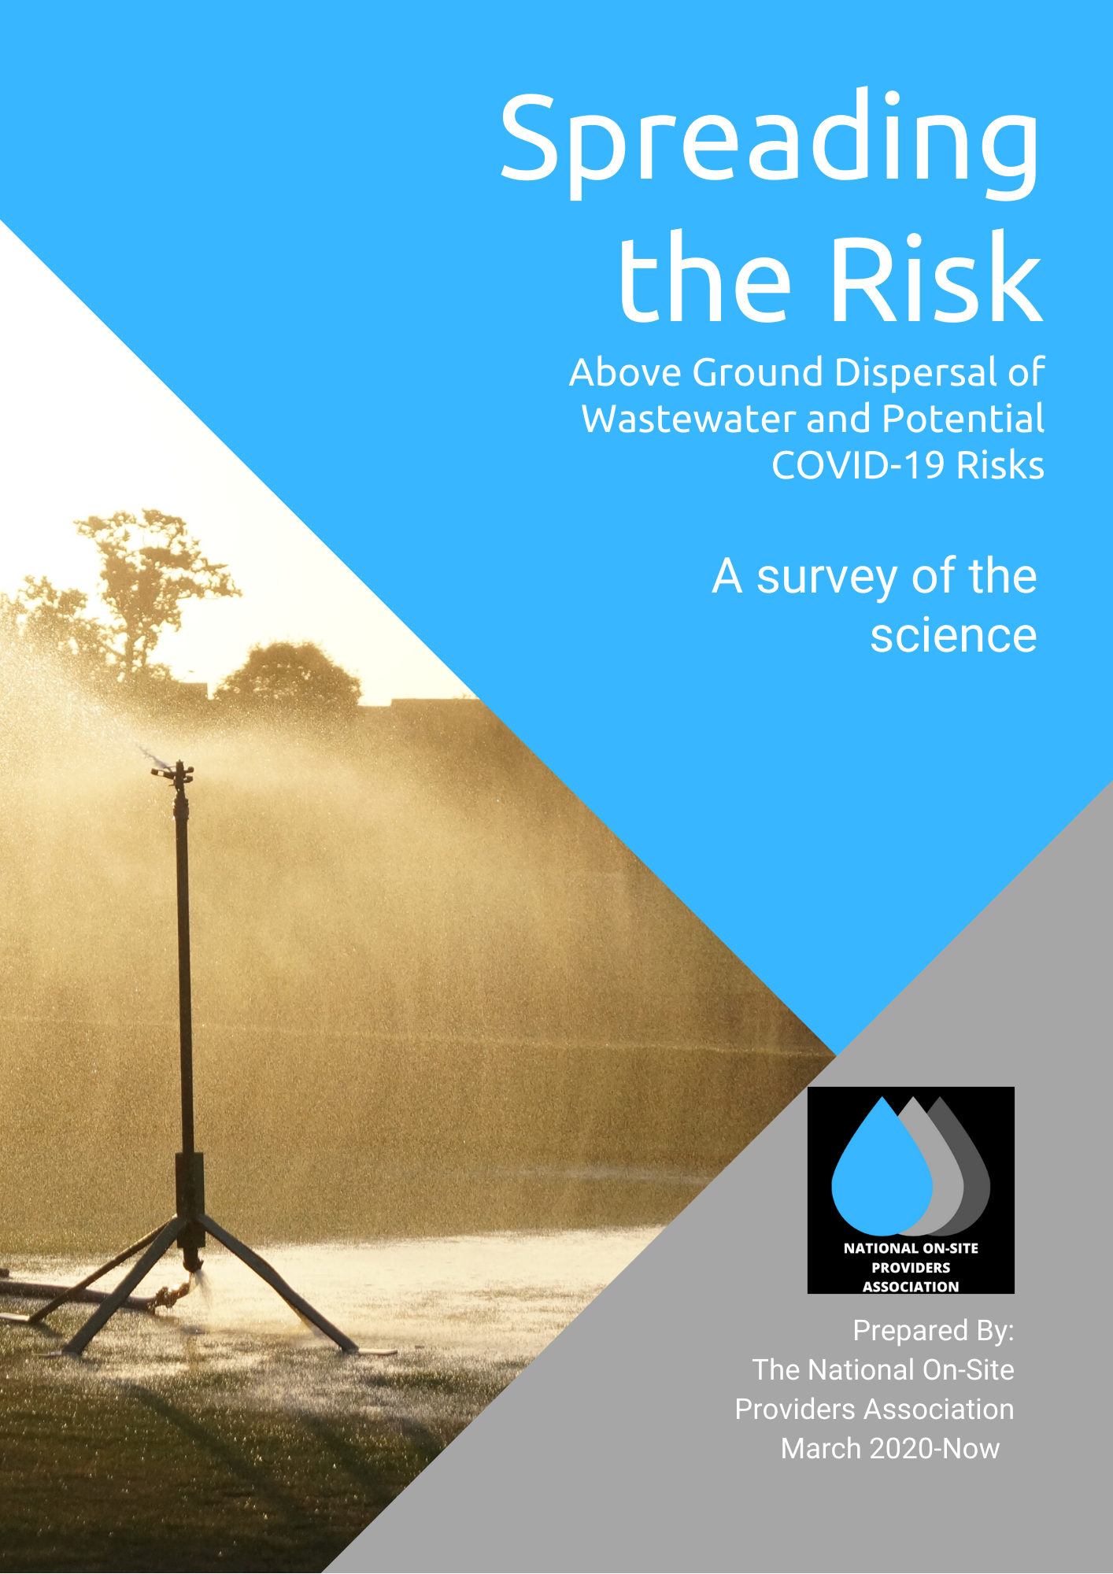

A SURVEY OF LITERATURE SINCE MARCH, 2020 IN BOTH SCIENCE-SPECIFIC AND GENERAL MEDIA.
THIS SUMMARY SUGGESTS A CONSENSUS HAS NOT YET BEEN FOUND REGARDING THE POTENTIAL PUBLIC HEALTH RISKS OF TRANSMISSION OF COVID-19 VIA ON-SITE DOMESTIC WASTEWATER TREATMENT SYSTEMS WHICH DISPERSE EFFLUENT ABOVE- GROUND.
THIS RAISES QUESTIONS ABOUT THE CURRENT RISK PROFILE OF THE CURRENT AUSTRALIAN STANDARD AS1546.3:2017 WHICH IGNORES BELOW-GROUND ADVANCED PASSIVE SYSTEMS.
THIS SUMMARY WILL BE UPDATED MONTHLY.
NOPA, 2020
“In theory, but I have only seen one study out of many that was able to culture virus in fecal matter. We don’t yet know how well it maintains infectivity. Other viruses have been found in the air around WWTPs (Wastewater Treatment Plants). We are currently collecting samples to look at this question.”

@linseymarr
Twitter feed of Dr. Linsey Marr, renowned airborne infection expert, in response to query from NOPA about whether there are viral infection risks of on-site, above ground, wastewater dispersal.
June 16, 2020
Link

“Dr. Marr is among a small but vocal group of scientists who are calling for more attention to be given to the airborne route of coronavirus transmission. Although the World Health Organization has been adamant that Covid-19 is not an airborne disease, a large body of evidence suggests people get sick by sharing the same air with an infected person…”

“…It’s hard to believe this pandemic could have spread the way it did so quickly around the world without the airborne route playing a role,” said Richard L. Corsi, dean of engineering and computer science at Portland State University and a specialist in indoor air quality. “It’s a frustration for people who understand aerosols and air pollution particles that this hasn’t received more attention. There are about a half-dozen people screaming about this from the rooftops.”

The Scientist, The Air and The Virus
New York Times
June 12, 2020
Link

"Our results clearly show that airborne transmission via respiratory aerosols represents the dominant route for the spread of COVID-19,"

"Our work suggests that the failure in containing the propagation of COVID-19 pandemic worldwide is largely attributed to the unrecognized importance of airborne virus transmission,"
Face Masks Critical in Preventing Spread of COVID-19
Texas A&M University (via Science Daily)
June 12, 2020
Link

“While transmission via direct or indirect contact occurs in a short range, airborne transmission via aerosols can occur over an extended distance and time. Inhaled virus-bearing aerosols deposit directly along the human respiratory tract.
Previous experimental and observational studies on interhuman transmission have indicated a significant role of aerosols in the transmission of many respiratory viruses, including influenza virus, SARS-CoV-1, and Middle East Respiratory Syndrome coronavirus (MERS-CoV).”
Identifying Airborne Transmission as the Dominant Route for the Spread of COVID-19
R.Zhang, et al.
Proceedings of the National Academy of Sciences of the United States of America
June 11, 2020
Link

“…based on the trend in the increase of infections, and understanding the basic science of viral infection spread, we strongly believe that the virus is likely to be spreading through the air. If this is the case, it will take at least several months for this to be confirmed by science. This is valuable time lost that could be used to properly control the epidemic by the measures outlined above and prevent more infections and loss of life.

Therefore, we plead that the international and national authorities acknowledge the reality that the virus spreads through air, and recommend that adequate control measures…be implemented to prevent further spread of the SARS-CoV-2 virus.”

Airborne Transmission of SARS CoV-2: The World Should Face the Reality
L.Morawska and J.Cao
Environment International (Via ScienceDirect)
Volume 139, June 2020
Link

“What’s really needed are more air sampling studies that can detect the virus in different locations and various air flow situations and then determine if enough virus is present in each case to infect people.”

Where Coronavirus is More Likely to be Airborne – 5 Places to Avoid
Bruce Y. Lee
Forbes
May 30, 2020
Link

“What can be done to limit airborne transmission? We propose a three-pronged approach targeting: (i) governments (building the knowledge base to inform holistic decision-making in the best interests of the public and the economy); (ii) built spaces (improving ventilation); and (iii) the public (protecting individuals from infection via personal measures)…

… It is important to learn lessons from past outbreaks and associated knowledge bases, as well as to understand and acknowledge the emerging challenge of airborne transmission under eased movement restrictions in the near future.”

Could Fighting Airborne Transmissions be the Next Line of Defence Against Covid-19 Spread?
P.Kumar and L.Morawski
City and Environment Interactions (via ScienceDirect)
May 28, 2020
Link

‘ “A lot of the evidence has been pointing to aerosol transmission of respiratory viruses,”
Influenza can be passed through the air, as can the virus that causes SARS.
“This particular virus, a lot of evidence is mounting.”
“It’s just shocking to me, quite honestly, that this has not been factored in.” ‘

Aerosol Scientist: COVID-19 is Likely Airborne
Quoting Dr Kimberley Prather
University of California, San Diego
WebMD
May 27, 2020
Link

“The evidence suggests that mitigating airborne transmission should be at the front of our disease-control strategies for COVID-19.”

We Cannot Keep Ignoring the Possibility of Airborne Transmission. Here’s how to Address it
Joseph Allen
Director, Healthy Buildings Program, Harvard School of Public Health
The Washington Post
May 27, 2020
Link

“Early warning of the risk of contracting COVID-19 via water currently is highly essential; when the virus is in the water you use, social distancing is not enough. During the current COVID-19 pandemic, screening has shown presence of the causative SARS-CoV-2 virus in stool samples, sewage and wastewater within large communal wastewater treatment plants throughout the world.”

Rapidly detecting faecal pollutions related to microbial infections, recently including COVID-19
Environmental Technology
May 15, 2020
Link

“(W)e should carefully examine our wastewater systems to ensure that there is minimal public exposure to untreated wastewater. This is likely to be a problem in areas that do not have adequate sanitation and water treatment…
…Research is still limited, but conventional municipal wastewater treatment plants that include disinfection…are likely effective at inactivating SARS-CoV-2. A greater concern from a public health standpoint is release of untreated or partially treated wastewater."
Risk of COVID-19 transmission through wastewater
Media Release, Northwestern University (US)
May 8, 2020
Link

“Environmental biologists at the University of Stirling (UK) have warned that the potential spread of COVID-19 via sewage "must not be neglected" in the battle to protect human health.”
Sewage Poses Potential COVID-19 Transmission Risk, Experts Warn
Media Release, University of Stirling, via Science Daily
May 6, 2020
Link

“A leading Israeli expert on contaminants in water called Sunday for urgent research to be carried out into the ability of the novel coronavirus in human faeces to survive in streams, groundwater, seawater and wastewater treatment facilities and on beaches.”

Could Wastewater Carry Coronavirus? Expert Says Research Needed Urgently
The Times of Israel
May 5, 2020
Link

“Based upon previous investigation into SARS, spread (of COVID-19) through aerosolization remains a potential secondary transmission method, especially within the built environment.”

Reducing COVID-19 Transmission in the Built Environment
Architect: The Journal of the American Institute of Architecture
May 4, 2020
Link

“The weight of the available evidence warrants immediate attention to address the significance of aerosols and implications for public health protection.”
Consideration of the Aerosol Transmission for COVID-19 and Public Health
Risk Analysis (Journal)
May 1, 2020
Link

“With so much still unknown about SARS-CoV-2, it is too early to say exactly how it spreads from person to person.
It is accurate to say that the virus can spread through infected droplets, but more evidence is needed before scientists can confirm that it is airborne.”
Is Coronavirus Airborne? COVID19 and Transmission
Medical News Today
May 2020
Link

(A paper in the Nature journal), “authored by scientists at Wuhan University in China, reported that aerosolised traces of viral genetic material, called RNA, were found in two hospitals – particularly in poorly ventilated spaces.
The highest concentration of the aerosol particles were found in a single-person mobile toilet that lacked ventilation.”
Coronavirus Experts Unable to Confirm or Deny Airborne Transmission as Multiple Studies Fail to Reach Verdict
The Independent
April 30, 2020
Link

“In confined spaces, however, aerosols are known to transmit other pathogens, including those that cause tuberculosis, measles, and chickenpox.
Aerosol transmission may also have played a role in the spread of the coronavirus that caused an outbreak of the respiratory infection SARS in Hong Kong in 2003.”
Tiny Airborne Particles May Carry the New Coronavirus
Medical News Today
April 30, 2020
Link

“…(C)urrent wastewater treatment procedures efficiently clear the virus. Worryingly, waterborne transmission may occur…where sewage treatment is far less efficient.”
Metropolitan Wastewater Analysis for COVID‐19 Epidemiological Surveillance
Research Paper, via ResearchGate
April 29, 2020

“I think its notable that there’s currently no epidemiological signal of infection via this (wastewater) pathway and no reported cases of any waterborne infection.

But that, of course, doesn’t mean that it can’t happen….

…it’s not an indication that there isn’t viable infective virus present.”

Personal Communication with Australian Academic (Off-the-Record)
April 29, 2020

“Aerosol transmission of SARS-CoV-2 due to poor ventilation may explain the community spread of COVID-19.”
Evidence of Probable Aerosol Transmission of SARS CoV-2 in a Poorly Ventilated Restaurant
Y.Li et al
Preprint Article in MedRxiv
April 22, 2020
Link

“(T)here are chances that coronaviruses may exist in and could maintain their viability in sewage and hospital wastewater, originating from the faecal discharge of infected patients.”
Scientific Imperatives for COVID-19: Water Sector
Current World Environment, via ResearchGate
April 22, 2020
Link

“Whilst COVID-19 is primarily a respiratory disease, numerous reports have confirmed detection of SARS- COV-2 RNA in the faeces of both symptomatic and asymptomatic COVID-19 patients. The virus can also be shed and transferred to wastewater via other bodily secretions including sputum.
Once faeces enter the wastewater system, the associated viral RNA can be detected by WBE techniques…..The stability and duration of possible detection of SARS-CoV-2 RNA in wastewater has not yet been determined.”
Monitoring Wastewater to Detect COVID-19
Office of the Chief Scientist, Report to the Australian Parliament
April 21, 2020

“Although we have not established the infectivity of the virus detected in these hospital areas, we propose that SARS-CoV-2 may have the potential to be transmitted via aerosols. Our results indicate that room ventilation, open space, sanitization of protective apparel, and proper use and disinfection of toilet areas can effectively limit the concentration of SARS-CoV-2 RNA in aerosols.
Future work should explore the infectivity of aerosolized virus. “
Aerodynamic analysis of SARS-CoV-2 in two Wuhan hospitals
Nature (Journal)
April 20, 2020
Link

“Scientists believe the infectious viral gastroenteritis caused by norovirus can be transmitted in aerosol form through toilet plumes…
The presence of coronavirus in the gut and the gastrointestinal symptoms associated with COVID-19 suggest coronavirus could be spread via faecal-oral transmission…

We need more research to ascertain whether this is the case.”
We don’t know for sure if coronavirus can spread through poo, but it’s possible
The Conversation (Australia)
April 14, 2020
Link

“Above ground dispersal systems often need to use additional chlorine dosing which can reduce but not necessarily eliminate bacteria and viruses. In addition, many of these systems are not properly maintained. As a result, the quality of the water being disposed aboveground cannot be guaranteed.

In the face of such uncertainty, and, as the COVID-19 virus hits home, the absence of any definitive understanding of the risks of above ground, treated wastewater dispersal is concerning.”

Covid-19 and Wastewater Dispersal – Are We Ignoring a Problem Area?
The Fifth Estate
April 2, 2020
Link

“Coronaviruses can remain infectious for long periods in water and pasteurized settled sewage, suggesting contaminated water is a potential vehicle for human exposure if aerosols are generated.”

Survival of Surrogate Coronaviruses in Water
Water Research (Journal) via Science Direct
April 2020
Link

“…(S)everal case studies have reported gastrointestinal symptoms and/or evidence that some patients with SARS-CoV-2 infection have viral RNA or live infectious virus present in faeces, which suggests that another possible route might be faecal–oral transmission.”

COVID-19: Faecal-Oral Transmission?
Nature (Journal)
March 25, 2020
Link

“By its very design, the wastewater plumbing system is a harbinger of pathogenic microorganisms with, under some circumstances, the potential to enable airborne transmission of viruses such as severe acute respiratory syndrome coronavirus 2 (SARS-CoV-2), which causes coronavirus disease 2019 (COVID-19).”
COVID-19: Mitigating Transmission Via Wastewater Plumbing Systems
The Lancent
March 23, 2020
Link

“…as viral fragments (of Coronavirus) have been found in excreta and because of other potential infectious disease risks from excreta, wastewater should be treated in well-designed and well-managed centralized wastewater treatment works.”
“Water, Sanitation, Hygiene, and Waste Management for the COVID-19 virus: interim Guidance”,
World Health Organisation Fact Sheet
March 23, 2020
Link

“Previous studies have shown that the virus can survive in wastewater for hours and even days without disinfection, and there have been reports that indicated sewage was a cause for the spread of SARS in Hong Kong in 2003.”

Majority of wastewater workers in Chicago, US told to work remotely due to potential COVID-19 transmission risks
Chicago Crusader
March 13, 2020
Link

